Skill Week-2
Task 1: To Apply Escape Sequences, Store Command History, Navigate Previous Commands, Navigate Next Commands, Update Input Buffer, Test Recall Functionality.
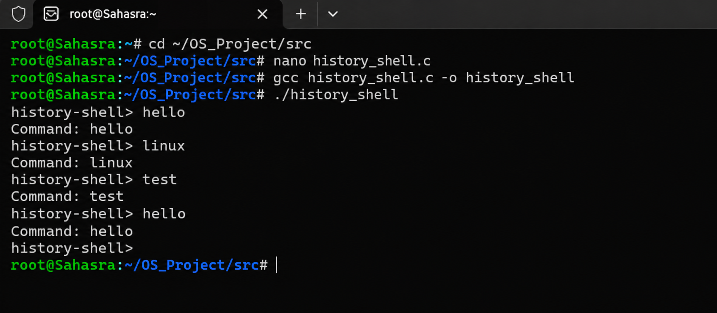
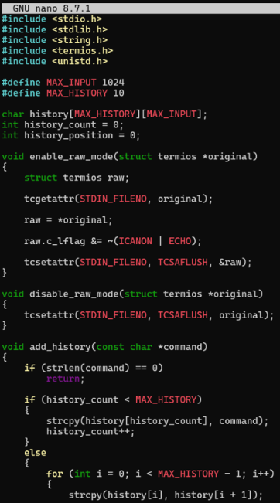
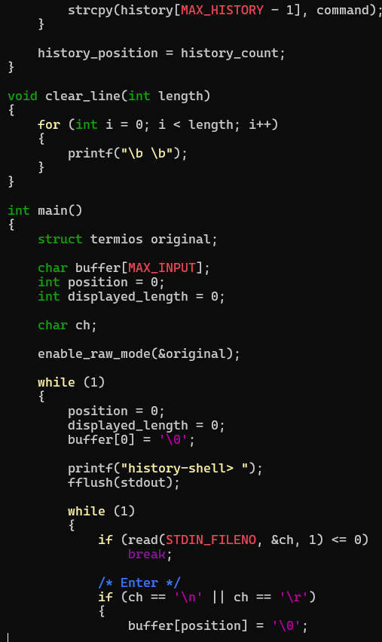
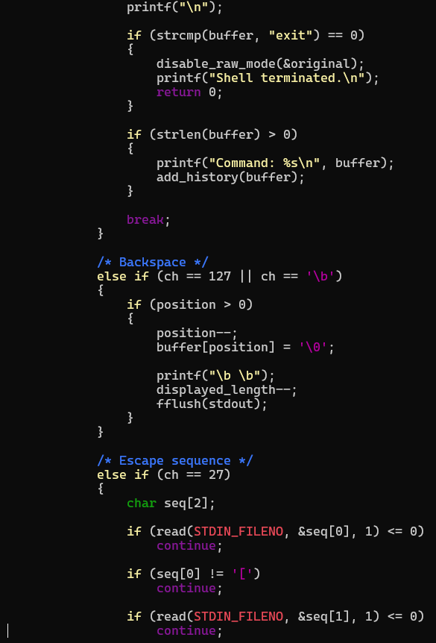
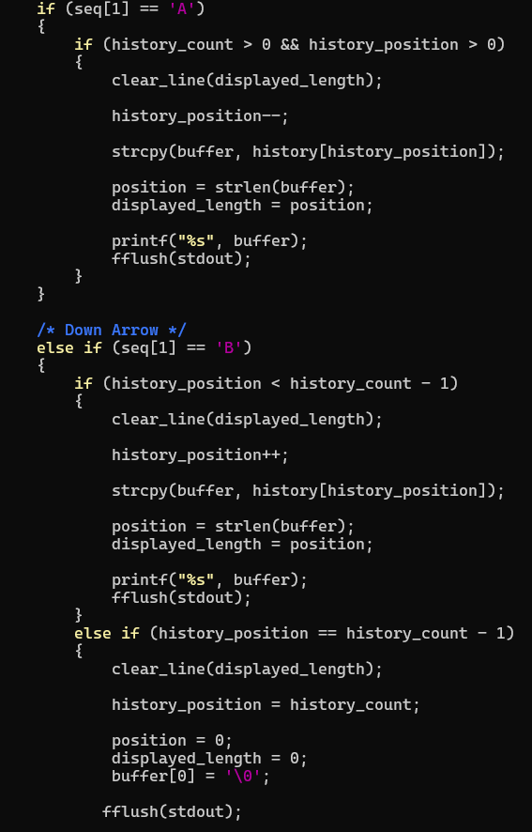
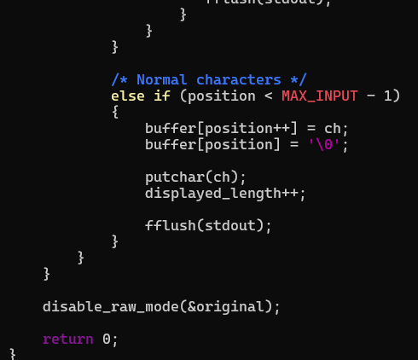
Task 2: To Allocate Buffers Dynamically, Resize Arrays, Prevent Buffer Overflow, Manage Linked Lists, Release Memory Correctly, Verify with Valgrind.
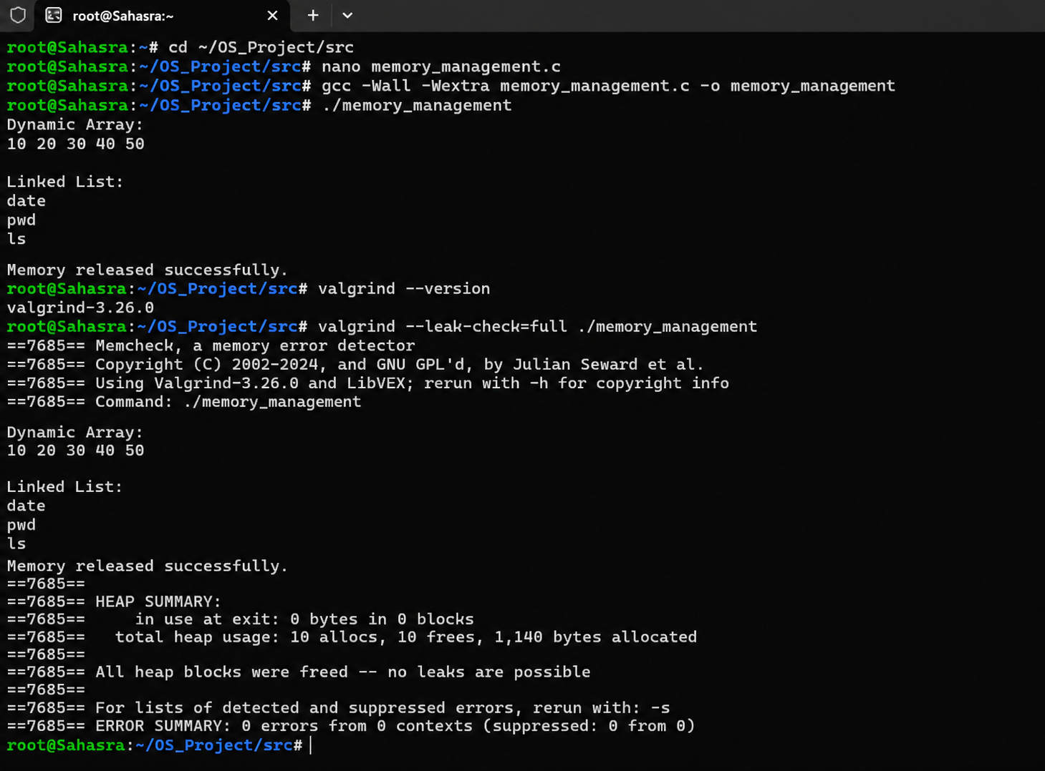

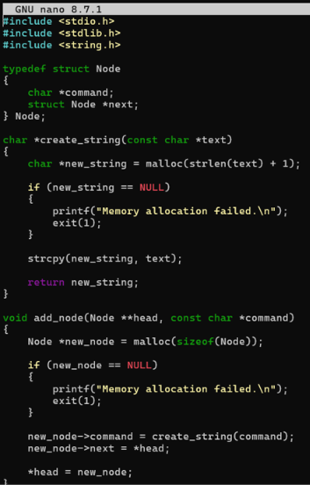
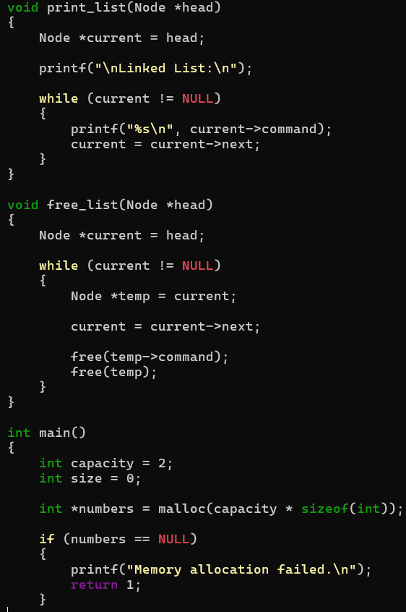
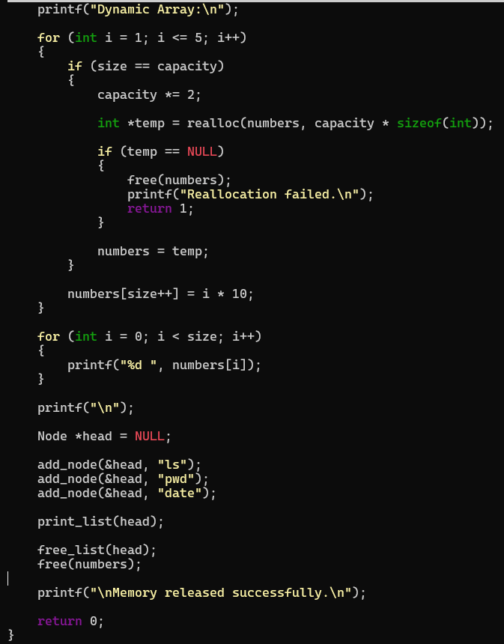
Task 3: To Split Input into Tokens, Identify Delimiters, Handle Whitespace, Create Token Structures, Validate Token Streams, Debug Parsing Output.
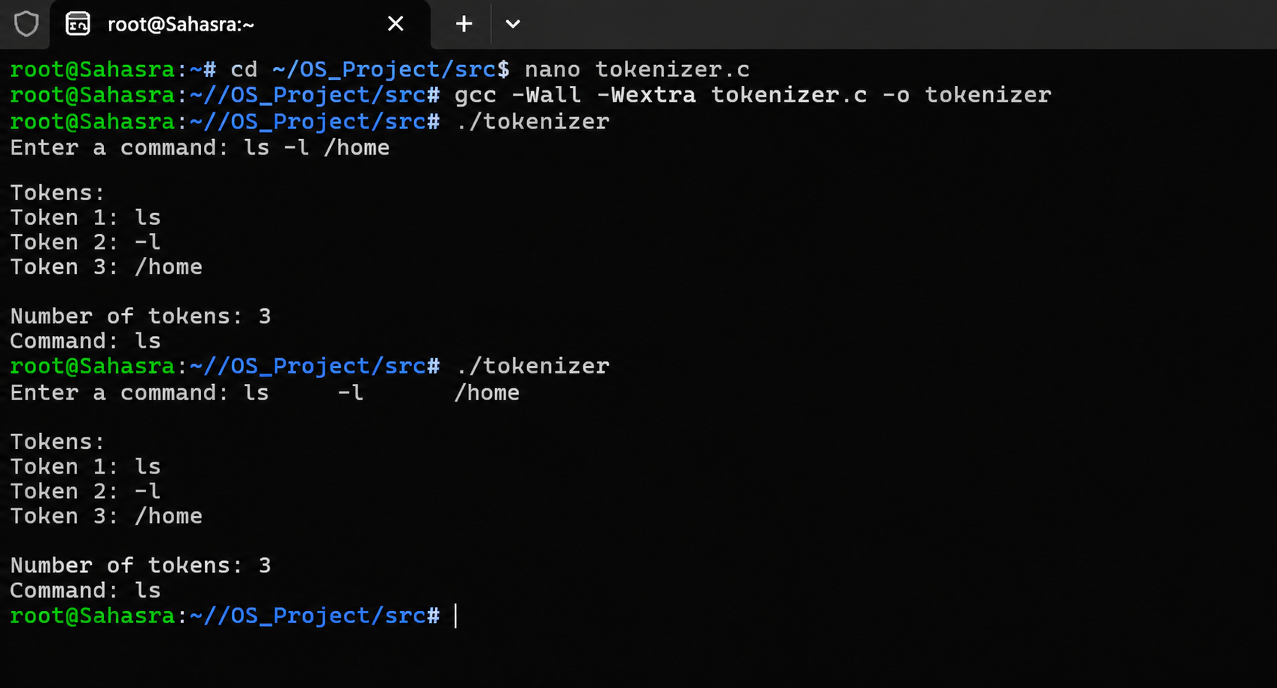

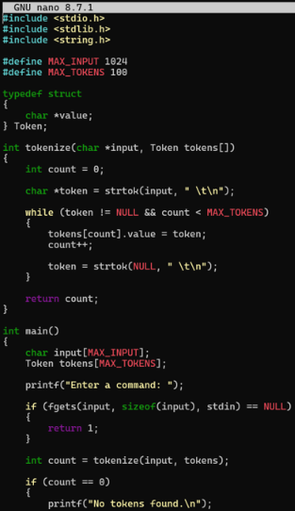
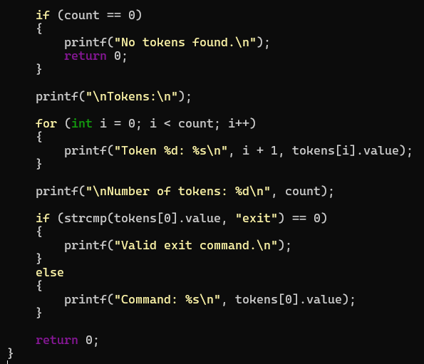
Task 4: To Design Parser Logic, Generate Parse Trees, Validate Syntax, Detect Errors, Handle Empty Commands, Produce Execution Structures
